Project Final Report

Introduction
The primary motivation behind this project is to improve digital accessibility for visually impaired individuals, a demographic for whom the internet often remains largely opaque. While modern screen readers can successfully vocalize text, they cannot interpret images that lack manual alt-text tags. By converting pixel data into descriptive speech, an automated captioning system acts as a "visual interpreter," bridging this crucial gap and making digital media significantly more accessible and navigable.
Therefore, the specific goal of this project is to design and implement a custom Hybrid Encoder-Decoder architecture capable of automatically captioning raw images with grammatically coherent English sentences.
Machine learning provides a highly reasonable and necessary approach for this task because image captioning requires bridging two distinct data modalities: spatial data derived from images and sequential data from natural language. Traditional rule-based algorithms fail to effectively address this complex mapping challenge. A deep learning approach is essential because it is uniquely capable of learning the non-linear mapping between these two distinct domains. Specifically, this project leverages machine learning by using a Convolutional Neural Network (CNN) to compress the input image into a dense semantic "content vector," while a Recurrent Neural Network (RNN) utilizes this spatial vector to generate the sequential text output.

Illustration / Figure
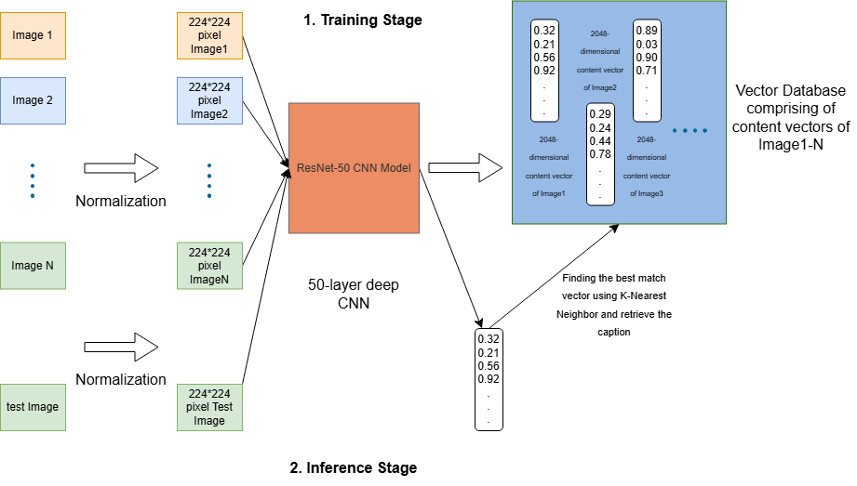
Fig 1. Overall architecture of my model implementation

Background & Related Work
The evolution of automated image captioning has transitioned from early template-based approaches to sophisticated deep learning architectures. This project’s methodology is heavily informed by several foundational works in the domain of visual-semantic mapping and sequence generation.
The structural baseline of our approach is rooted in the "Show and Tell" framework proposed by Vinyals et al. (2015). They pioneered the use of an end-to-end encoder-decoder architecture for image captioning, demonstrating that a Convolutional Neural Network (CNN) could effectively encode an image into a fixed-length representation, which a Recurrent Neural Network (RNN) could then decode into a descriptive sentence. To optimize the spatial encoding process within this framework, our model relies on the Deep Residual Learning architecture developed by He et al. (2015). Their introduction of ResNet architectures—specifically ResNet-50—allows for the extraction of highly robust spatial feature maps without suffering from the vanishing gradient problem inherent in exceptionally deep networks.
Further understanding of how to align these extracted visual features with natural language is drawn from Karpathy and Fei-Fei Li (2015). Their research utilized ranking losses to associate specific image regions with corresponding text fragments, establishing a critical foundation for granular visual-semantic alignment. This paradigm of matching text to visual data is empirically grounded by the work of Hodosh et al. (2013), who framed image description as a ranking task and established the Flickr8k dataset. By providing 8,000 images paired with 40,000 human-written captions, Hodosh et al. supplied the standardized benchmarking data necessary to validate and compare the performance of generative models against human ground truth.
Finally, to address the limitations of compressing an entire image into a single, fixed-length context vector, our architecture integrates the "Attention" mechanism introduced by Xu et al. (2015) in their "Show, Attend and Tell" paper. By allowing the LSTM decoder to dynamically calculate attention weights and focus on specific spatial regions of the image during each time step of sequence generation, this mechanism significantly improves descriptive accuracy. This concept was later advanced by Anderson et al. (2018), whose "Bottom-Up and Top-Down" attention model integrated object detection networks to calculate attention at the level of specific objects rather than generic spatial grids, providing a modern benchmark for object-level captioning that informs our model's evaluation.

Data Processing
The primary source of data for this project is the established Flickr8k dataset, which provides 8,000 images paired with 40,000 human-written captions. To demonstrate independent data collection capabilities, I also incorporated 20 personal images, captured using my Canon EOS R50 camera over the past two months. I manually generated five descriptive captions for each of these 20 personal images, resulting in 100 new captions. Using standard Python data analysis tools, I inspected the dataset to verify that every uploaded image had exactly five corresponding captions. These newly collected images and their captions were added directly to the test set to evaluate the model's performance on entirely new, real-world data, while the primary dataset was split into training, validation, and test sets.
Prior to model ingestion, all raw visual data required structural uniformity. I generated an Image Size Distribution histogram to analyse the original dimensions, which showed a wide variance in image widths and heights ranging roughly from 250 to 500 pixels. To resolve this variance and ensure a consistent input format for the Encoder-Decoder architecture, all images were pre-processed and strictly resized to 224x224 pixels. Following the resize operation, the pixel arrays were standardized using ImageNet-based normalization.
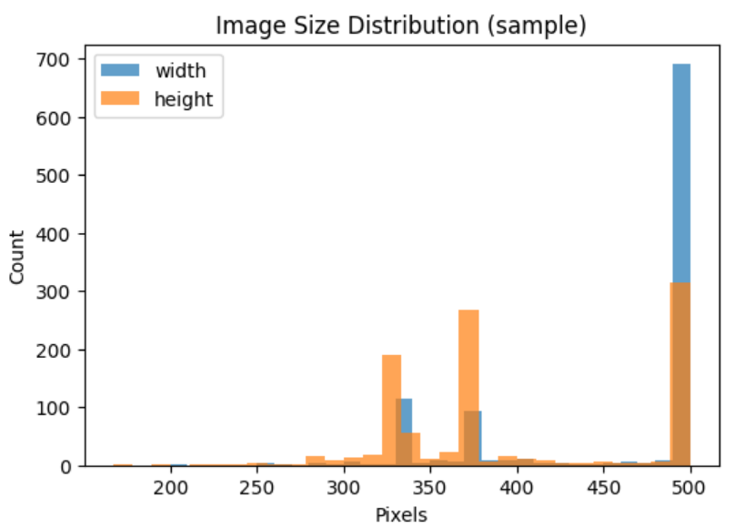
Fig 2 Image size distribution done using EDA
For the sequential language data, I conducted exploratory data analysis (EDA) to gain a holistic view of the text, which included calculating the total number of tokens across all captions and analysing their relative frequencies. This analysis informed the subsequent cleaning process. First, I converted all captions to lowercase and stripped the text of punctuation. Next, I built a vocabulary dictionary, actively filtering out rare tokens that appeared fewer than five times across the entire corpus. Finally, to prepare the text for the RNN decoder, each cleaned caption was converted into an integer sequence, marked with distinct beginning and concluding tokens, and zero-padded to a consistent length of 35 tokens to allow for standardized batching during training.

References
[1] P. Anderson, et al. Bottom-up and top-down attention for image captioning and visual question answering. CVPR, 6077-6086, 2018.
[2] M. Hodosh, et al. Framing image description as a ranking task. Journal of Artificial Intelligence Research, 47, 853-899, 2013.
[3] A. Karpathy and L. Fei-Fei. Deep visual-semantic alignments for generating image descriptions. CVPR. 3128-3137, 2015.
[4] O. Vinyals, et al. Show and tell: A neural image caption generator. CVPR, 3156-3164, 2015.
[5] K. Xu, et al. Show, attend and tell: Neural image caption generation with visual attention. ICML, 2048-2057, 2015.
[6] Kaiming He, Xiangyu Zhang, Shaoqing Ren, and Jian Sun. Deep Residual Learning for Image Recognition. arXiv preprint arXiv:1512.03385, 2015.

